Docker

Contents:

What is Docker?

Why use Docker?

How does it work?

Docker Architecture.

Docker daemon.

Docker client.

Docker registries.

Dockerfile.

Docker Image.

Containers

- Basic Commands

Listing Hash Values of Docker Images.

What is Docker?
Docker is a container platform that allows you to build, test and deploy applications quickly. A developer defines all the applications and it’s dependencies in a Dockerfile which is then used to build Docker images that defines a Docker container. Doing this ensures that your application will run in any environment.

Why use Docker?

- Using Docker can help you ship your code faster, gives you control over your applications. You can deploy applications on containers that make it easier for them to be deployed, scaled, perform rollbacks and identify issues. It also helps in saving money by utilizing resources.

- Docker-based applications can be seamlessly moved from local development machines to production deployments. You can use Docker for Microservices, Data Processing, Continuous Integration and Delivery, Containers as a Service.

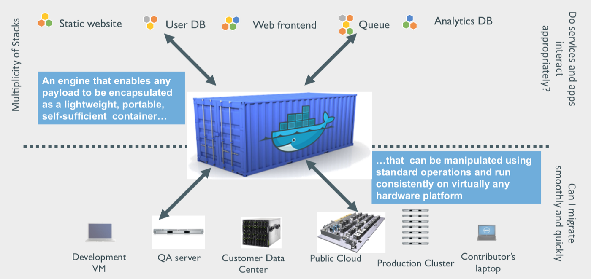

How does it work?

Containerization vs Virtualization

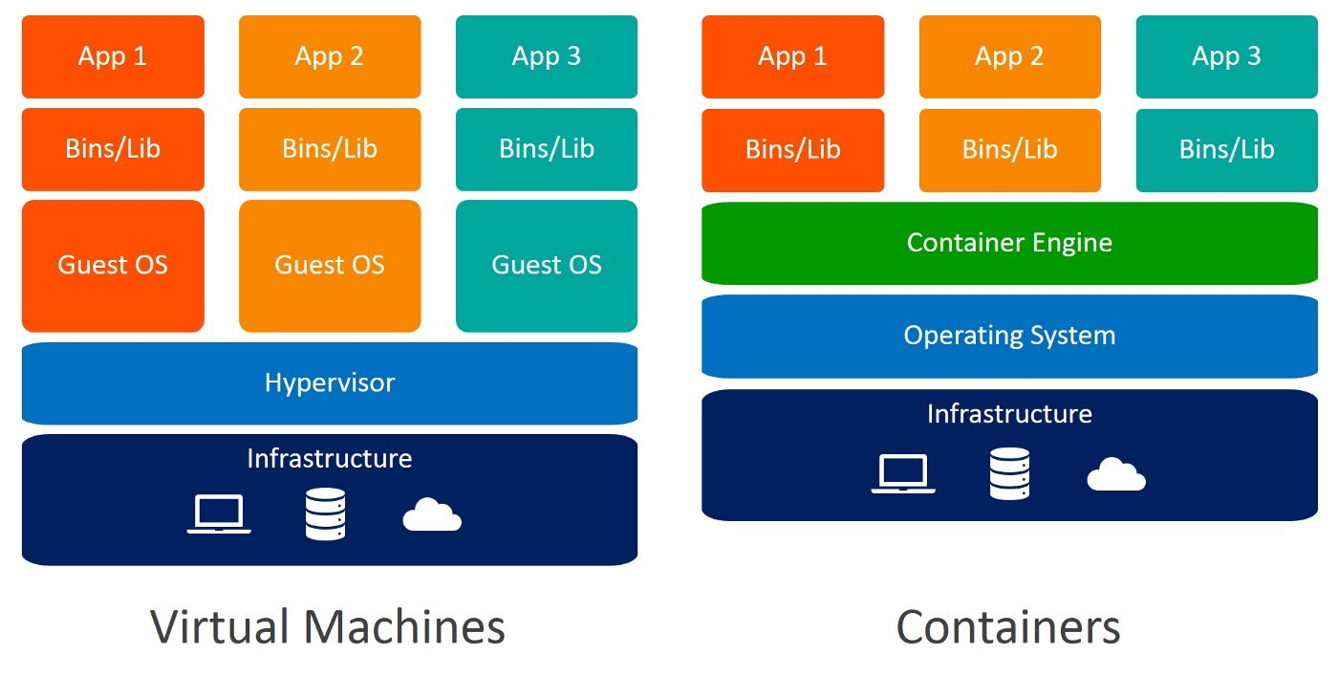

An application on a VM requires a guest OS and thus an underlying hypervisor to run. Hypervisor is used to create multiple machines on a host operating system and it manages virtual machines. These virtual machines have their own operating system and do not use the host’s operating system. They have some space allocated.
A container encapsulates an application with its own operating environment. It can be placed on any host machine without special configuration, removing the issue of dependencies. VM is hardware virtualization, whereas containerization is OS virtualization. In comparison, virtualization is the creation of a virtual version of something such as an operating system, server or a storage device or network resources. Essentially, containerization is a lightweight approach to virtualization.

Docker Architecture
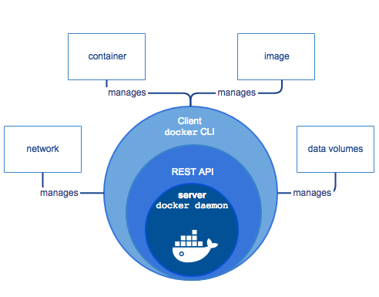

Docker uses a client-server architecture. The Docker client talks to the Docker daemon, which does the heavy lifting of building, running, and distributing your Docker containers.

Docker daemon
It listens to the API requests being made through the Docker client and manages Docker objects such as images, containers, networks, and volumes.

Docker client
This is what you use to interact with Docker. When you run a command using docker, the client sends the command to the daemon, which carries them out. The Docker client can communicate with more than one daemon.

Docker registries
This is where Docker images are stored. Docker Hub is a public registry that anyone can use. When you pull an image, Docker by default looks for it in the public registry and saves the image on your local system on DOCKER_HOST. You can also store images on your local machine or push them to the public registry.

Dockerfile
Describes steps to create a Docker image. It’s like a recipe with all ingredients and steps necessary in making your dish. This file can be used to create Docker Image. These images can be pulled to create containers in any environment. These images can also be store online at docker hubs. When you run docker image you get docker containers. The container will have the application with all its dependencies.

- Create a file named ‘Dockerfile’
- By default on building, docker searches for ‘Dockerfile’ $ docker build -t myimage:1.0 .
- During building of the image, the commands in RUN section of Dockerfile will get executed. $ docker run ImageID
- The commands in CMD section of Dockerfile will get executed when you create a container out of the image.

Docker Image
A Docker Image is a file that defines a Docker Container. It is similar in concept to a snapshot of a VM. A container that moves from one Docker environment to another with the same OS will work without changes because the image includes all of the dependencies needed to execute the code. Docker Image is run to create a docker container. Images are immutable. Once built, the files making up an image do not change. Images can be stored locally or remote locations like hub.docker.com.

Basic Commands

- $ docker images (Lists Docker Images)
- $ docker run image (creates a container out of an image)
- $ docker rmi image (deletes a Docker Image if no container is using it)
- $ docker rmi $(docker images -q) (deletes all Docker images)
- $ docker ps (list all containers)
- $ docker run ImageName/ID (checks locally for image, if not available it will go to registry and then go to DOCKER_HOST)
- $ docker start ContainerName/ID
- $ docker kill ContainerName/ID (Stops a running container)
- $ docker rm ContainerName/ID (Deletes a stopped container)
- $ docker rm $(docker ps -a -q) (Delete all stopped containers)

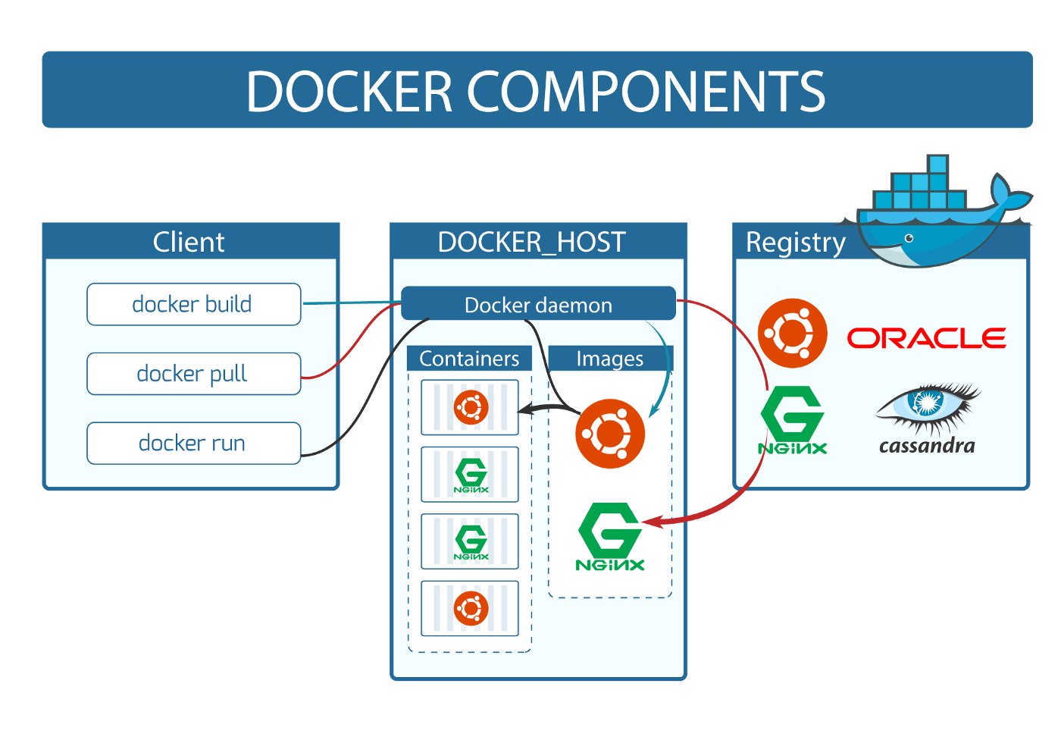
Docker can build images automatically by reading instructions from a DockerFile. A single image can be used to create multiple containers.

Images are built in layers. Each layer is an immutable file, but is a collection of files and directories. The last layer can be used to write out data to. Layers receive an ID, calculated via a SHA 256 hash of the layer contents. Thus, if the layer contents change- Notice the IMAGE ID below and the Hash Values given above, the first 12 characters of the hash are equal to the IMAGE ID, the SHA 256 hash changes as well. Note: The Image ID listed by docker commands (ie ‘docker images’) is the first 12 characters of the hash. These hash values are referred to by ‘tag’ names.

Containers
A container is a runnable instance of an image. This is where your application is running. You can manage containers using the Docker API or CLI. You can connect a container to one or more networks, attach storage to it, or even create a new image based on its current state. If we delete a container the data will be lost! Because when the container went down and we brought it back up, the last layer got created again as a new layer. This helps in development if you don’t want to store record for each test. To be persistent, use volumes to store data.

